

Rocket.Chat : Technical assessment - Rocket.Chat Enterprise Solutions team

Technical Support Analyst position – PART 1

Submitted by : Millard Louise Pascua

Date : 10/28/2020

**Table of Contents**

Summary of this Document . . . . . . . page 3

**SETUP SERVER:**

Download and Install the Latest VirtualBox . . . . . . . page 3

Download OS Ubuntu 19.04.iso . . . . . . . page 3

Creating a Virtual Machine in “Oracle VM VirtualBox Manager” . . . . . . . page 3

Mounting OS Ubuntu 19.04.iso to the newly created VM . . . . . . . page 3

Installing Ubuntu 19.04(64-bit) to the newly created VM . . . . . . . page 3

**DEPLOYMENT OF ROCKET.CHAT SERVER INSTANCE:**

Installation of Rocket.Chat in OS Ubuntu.19.04 . . . . . . . page 4

Setting the Rocket.Chat Server . . . . . . . page 5

**ACCESSING ROCKET.CHAT TO THE INTERNET**

Exposing “localhost” through a secure location . . . . . . . page 6

Access Rocket.Chat to the Internet . . . . . . . page 7

Summary of this Document:

The following instructions are the steps in creating a server until installing Rocket.Chat in the newly installed server and accessing it. The Operating Sytem used for this Technical Challenge is Ubuntu 19.04(64-bit). As there are many ways to install the Rocket.Chat server, the method used is via Snap. Snap are packages works across different Linux distributions that let you install and configure. Once Rocket.Chat server is installed and running. One of the requirements is, that it is accessible and the tool used is “Ngrok” that exposes the localhost through a secure connection. Once the “Ngrok” is running, the Rocket.Chat service can be access to the internet.

Please do take note that ngrok used in this technical challenge is a free trial and is limited to 8hrs. That may require the reviewee to notify the applicant to run ngrok or provide the time to access the environment within the limitation of the free trial.

**SETUP SERVER:**

* Download and Install the latest VirtualBox.

Link: <https://www.virtualbox.org/>

* + Version/Filename: VirtualBox-6.1.16-140961.Win.exe
  + Once download completes, install VirtualBox to preferred location.
* Download OS Ubuntu 19.04.iso.
  + Link: <http://old-releases.ubuntu.com/releases/19.04/>

* Note that Ubuntu 19.04 is an old release and isn't available in their main page: <https://ubuntu.com/download/desktop>

* Creating a Virtual Machine in “Oracle VM VirtualBox Manager”:
  + In Oracle VM VirtualBox Manager window, select the "New" button to create a virtual machine.
    - Name VM and provide Operating System.
      * OS: Ubuntu(64-bit)
    - Adjust memory to preferred size, then hit Next.
    - Hard disk; select “Create a Virtual hard disk now”, then hit Create.
    - Hard disk file type; select “VDI (Virtual Disk Image)”, then hit Next.
    - Storage on physical hard disk; select “Dynamically allocated”, then hit Next.
    - File Location and Size; select the file size to 20.00GB, then hit Create.
  + Notice the VM will be created and will be added to the list.
* Mounting OS Ubuntu 19.04.iso to the newly created VM.
  + Highlight the new created VM(OS:Ubuntu 19.04) and select the “Setting” icon.
  + Navigate to the “Storage” in the accordion tab found in the left side.
  + Select the Empty disk under Controller IDE.
    - On the “Optical Drive”, navigate your Ubuntu 19.04.iso. Then hit OK.
* Installing Ubuntu 19.04(64-bit) to the newly created VM.
  + Highlight the new created VM and select the “Start” icon to run the VM.
  + Once VM is running, the installation window for Ubuntu pops up.
  + Go through the installation process with the following settings/options selected:
    - Select “Install Ubuntu”.
    - Keyboard Layout; leave the options as is and hit Continue.
    - Update and other software; select the “Normal Installation”, then hit Continue.
    - Installation Type; select “Erase disk and Install Ubuntu”, then hit “Install Now”.
    - Time Zone; select the preferred time zone, then hit Continue.
    - Username and Password; enter preferred username and password, then hit Continue.
    - Once installation completed; it will require to restart VM.

**DEPLOYMENT OF ROCKET.CHAT SERVER INSTANCE:**

* Installation of Rocket.Chat in OS Ubuntu.19.04.
  + Navigate and open the Terminal window. Enter this command to install Rocket.Chat.
    - Command: sudo snap install rocketchat-server
  + Once installation is complete, enter this command to see if rocket chat is Rocket.Chat Service is running.
    - Command: sudo service snap.rocketchat-server.rocketchat-server status
    - 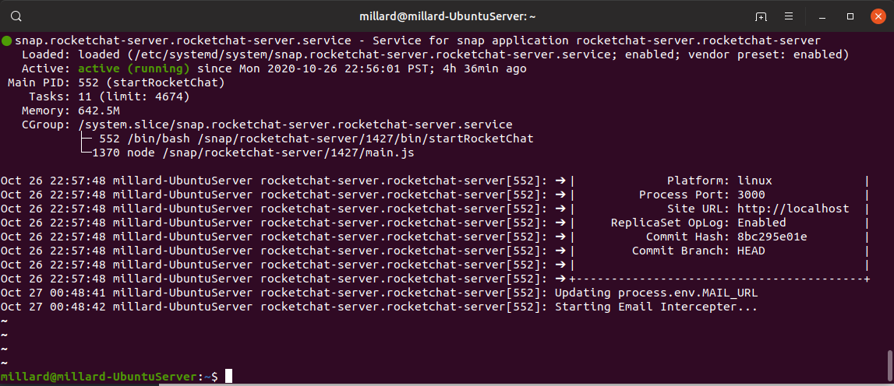Notice that the active status is in green font, as seen below:
* Setting the Rocket.Chat Server.
  + Browse to “http://localhost:3000” and setup Rocket.Chat as seen below.
    - 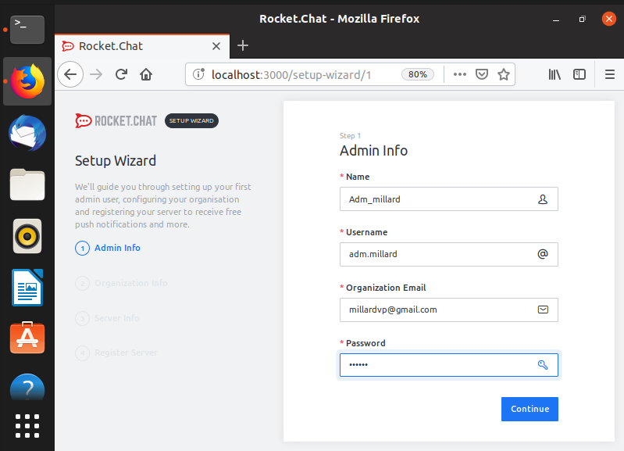Admin Info:
    - 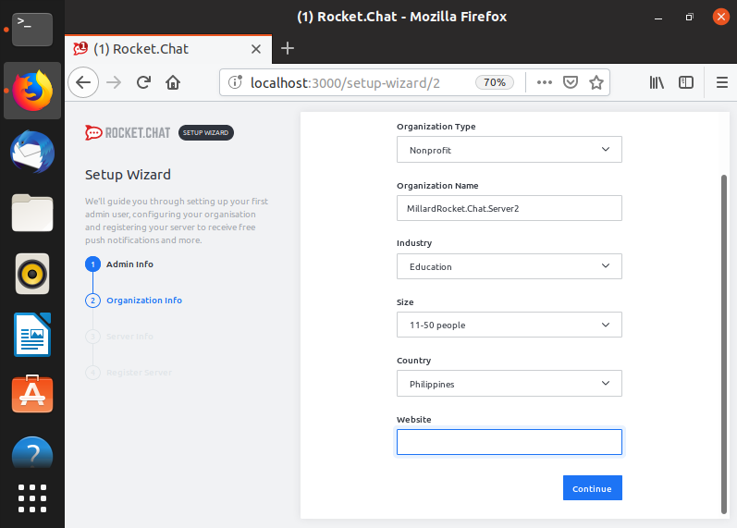Organization Info:
    - 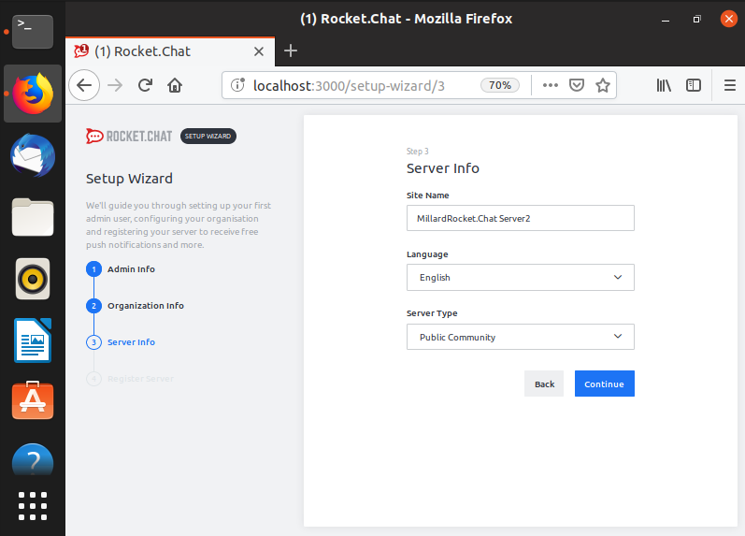Server Info:
    - 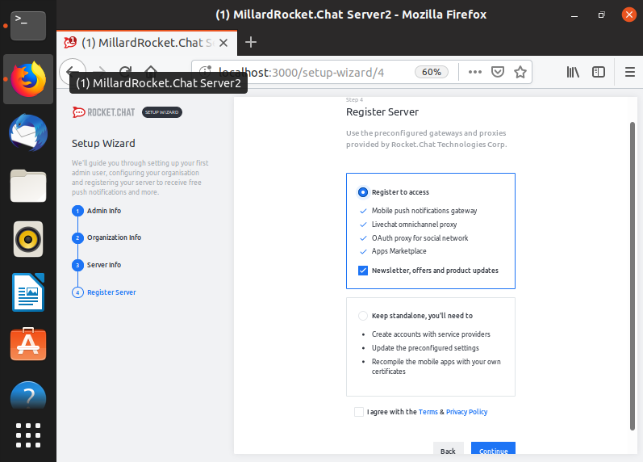Register Server:

**ACCESSING ROCKET.CHAT TO THE INTERNET**

* Exposing “localhost” through a secure location.
  + Download and extract “Ngrok” to the Rocket.Chat Server.
    - Link: <https://ngork.com/download>
  + Once download and extraction completed. Move the extracted Ngrok executable file to /usr/bin. Please see reference below.
  + Run the ngrok command to expose the localhost through a secure location.
    - Open the Terminal window and enter this command.
      * Command: ngrok http 3000
        + 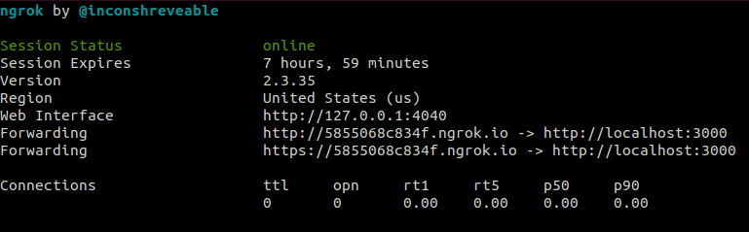Note that 3000 is the process port for Rocket.Chat Server.
      * Once ngrok http 3000 is running, it will display the ngrok console UI in the terminal with the public URL and your local webserver is accessible to the internet. Take note the Forwarding <https://5855068c834f.ngrock.io> as it is the temporary/public URL.
* Access Rocket.Chat to the internet.
  + 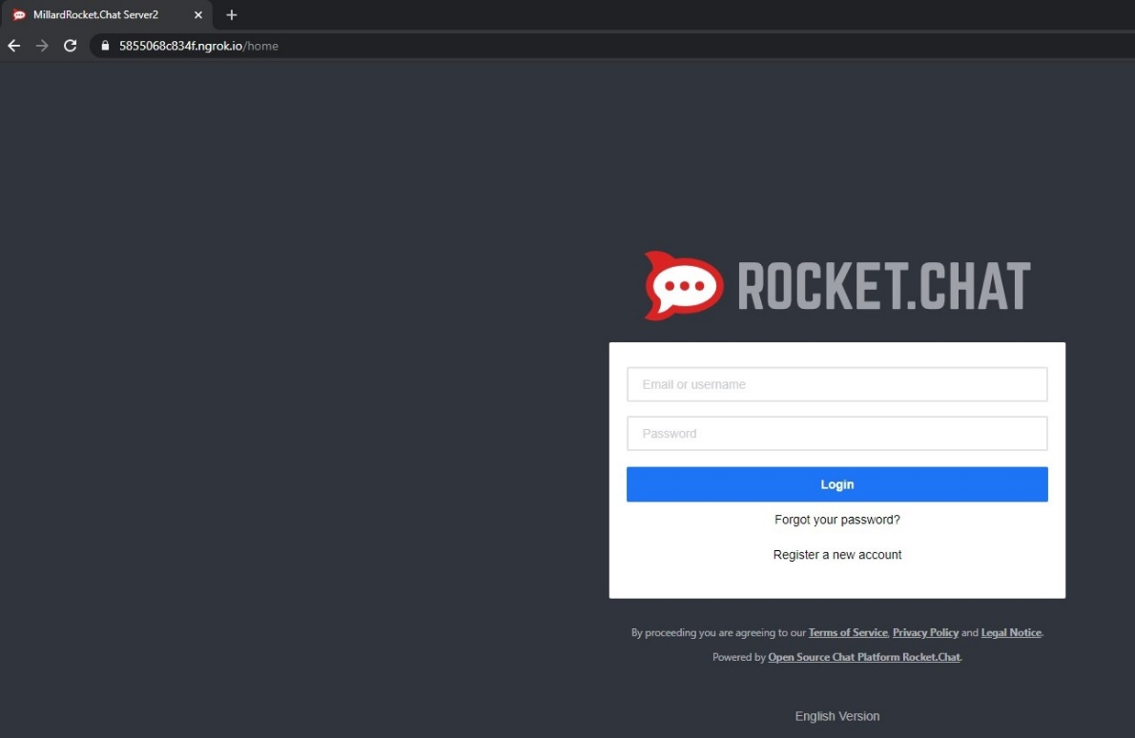Open a new browser and browse to <https://5855068c834f.ngrock.io> as seen below:
  + Login with these credentials to access the home page.
    - Username: adm.millard
    - 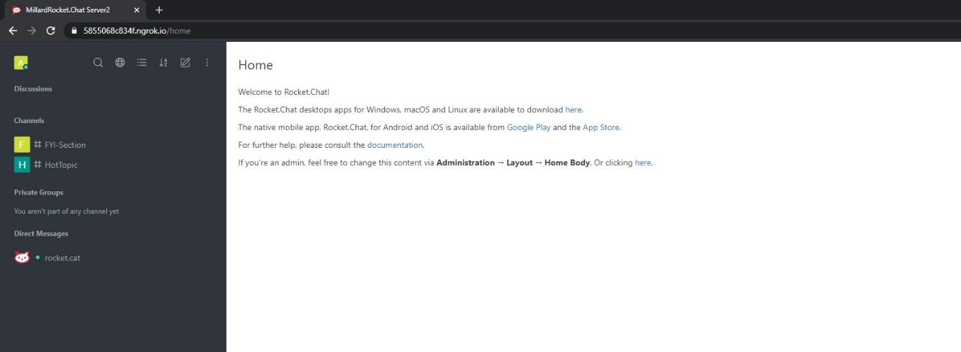Password: 071203